Research Report: Arduino-Based Industrial Fault Detection with Condition Monitoring (Calor Gas)

Author: Devon Ross Fry

Institution: Tecol/Calor Gas

Date: 21/02/2025

Abstract

This project aimed to design and prototype a low cost, Arduino based vibration monitoring system for hazardous industrial environments, specifically targeting the head down spinner of Calor Gas’s 3-stage leak detector. The system integrates a vibration sensor (SW-420), Arduino Uno and Python based data visualisation to detect anomalies and enable predictive maintenance. Challenges included ATEX compliance, sensor accuracy and precision, and real time data analysis. Results demonstrated the feasibility of cost-effective vibration monitoring, though limitations in accuracy and safety compliance were identified. Future work will focus on integrating intrinsically safe (IS) barriers and refining signal processing algorithms.

1. Introduction

Industrial machinery, particularly in hazardous environments like Calor Gas’s LPG filling and storage facilities, require robust condition monitoring to prevent unplanned downtime and safety risks. The head down spinner of the 3-stage leak detector experiences excessive vibration under higher-than-average pressure, which leads to mechanical stress. Traditional systems like the Fluke 3563 are costly, prompting this investigation into Arduino and cost-effective based alternatives.

This research project is grounded in condition-based maintenance theory, which emphasises the use of real time data collection, in order to predict and prevent industrial equipment failures. By integrating low-cost vibration monitoring with predictive analytics, the project aligns with condition-based maintenance principles while also addressing the cost barriers that are linked to standard commercial systems. Also, the project looks at reliability centred maintenance, to evaluate the trade-offs between cost, accuracy and safety in hazardous environments.

The project addresses the following objectives:

* Objective 1: Research and evaluation of current industrial monitoring systems, that could be applied to the project problem.
* Objective 2: Development of a basic Arduino based sensor system for the head down spinner.
* Objective 3: Investigation and development of a real time monitoring prototype, through software (Python).
* Objective 4: Analysis of hypothetical collected data to identify failure patterns and predictive maintenance needs.

2.Literature Review

2.1 Vibration Monitoring Systems

* Smith et al. highlighted the importance of accelerometers over basic vibration switches for industrial applications, though low-cost sensors like the SW-420 lack the resolution for early fault detection.
* Wang et al. compared FFT, and wavelet transforms, recommending FFT for simplicity but noting wavelet superiority for transient faults.
* Seeed Studio show the importance of researching different types of sensors, such as Eddy current, velocity, strain gauge sensor and piezoelectric accelerometer and their suitability for industrial applications. This effected the choice when researching sensors for the prototype.
* Data visualisation was a main milestone and objective for the project, this required research into visualisation techniques. Ravikiran A S, documented in an article the uses of different data visualisation techniques using Python code, and how different graphs are plotted with code that relates to their libraries. Research here directly impacted the choice, during the prototype phase and it was critical research into the feasibility of real time monitoring.

2.2 ATEX Compliance

* European Commision mandates energy limits to less that 100 micro joules and IS barriers for zone 2 hazardous areas.
* Muller et al. demonstrated Arduino modifications for ATEX compliance, using Zener diode barriers to limit current to 80mA, however they noted that standard Arduino components are not intrinsically safe and require additional modifications for hazardous environments. The research here guided the proposed safety modifications for future work, though full ATEX certification and extended research was beyond the scope of the project.

2.3 Cost effectiveness

* Petrova et al. found that Arduino reduces predictive maintenance costs by 70% when compared to SCADA systems. Their study highlighted the potential of Arduino for small scale industrial applications, especially in non-hazardous environments. However, they also noted that low-cost systems often lack the accuracy and reliability of commercial solutions, reinforcing the need for research into current industrial solutions.

2.4 Real time Data Analysis and Visualisation

* Real time monitoring systems require robust software for data collection, analysis and visualisation. Python has emerged as a popular choice, due to its extensive libraries (pandas, matplotlib, numpy, CSV, serial, time) and ease of integration with hardware like Arduino. Studies by Lee et al. (2021) demonstrated the effectiveness of Python for real time data visualisation in industrial applications, though they also highlighted challenges such as latency and noise. Research here showed the importance of Python libraries in general for different uses and has impacted my personal career for how I approach future research in regarding software.
* Data visualisation was a main milestone and objective for the project, this required research into visualisation techniques. Ravikiran A S, documented in an article the uses of different data visualisation techniques using Python code, and how different graphs are plotted with code that relates to their libraries. Research here directly impacted the choice, during the prototype phase and it was critical research into the feasibility of real time monitoring.

3.Methodology

3.1 Hardware Design

The hardware design was informed by research and the literature on low-cost vibration monitoring systems. The prototype uses an Arduino Uno (£20), an SW-420 vibration sensor (£3.79), LEDs and a breadboard. A temperature sensor was added for supplementary pressure monitoring, as temperature changes can indicate pressure variations in industrial machinery, and if temperature is too low, can effect IS circuitry.

Components

* Arduino Uno (£20), SW-420 Vibration sensor (£3.79), LEDs, breadboard.
* Temperature sensor added for supplementary pressure monitoring.

Circuit Design

* Initial prototype used basic LED alerts (Figure 1).
* Final iteration included serial communication and Python integration (Figure 2).

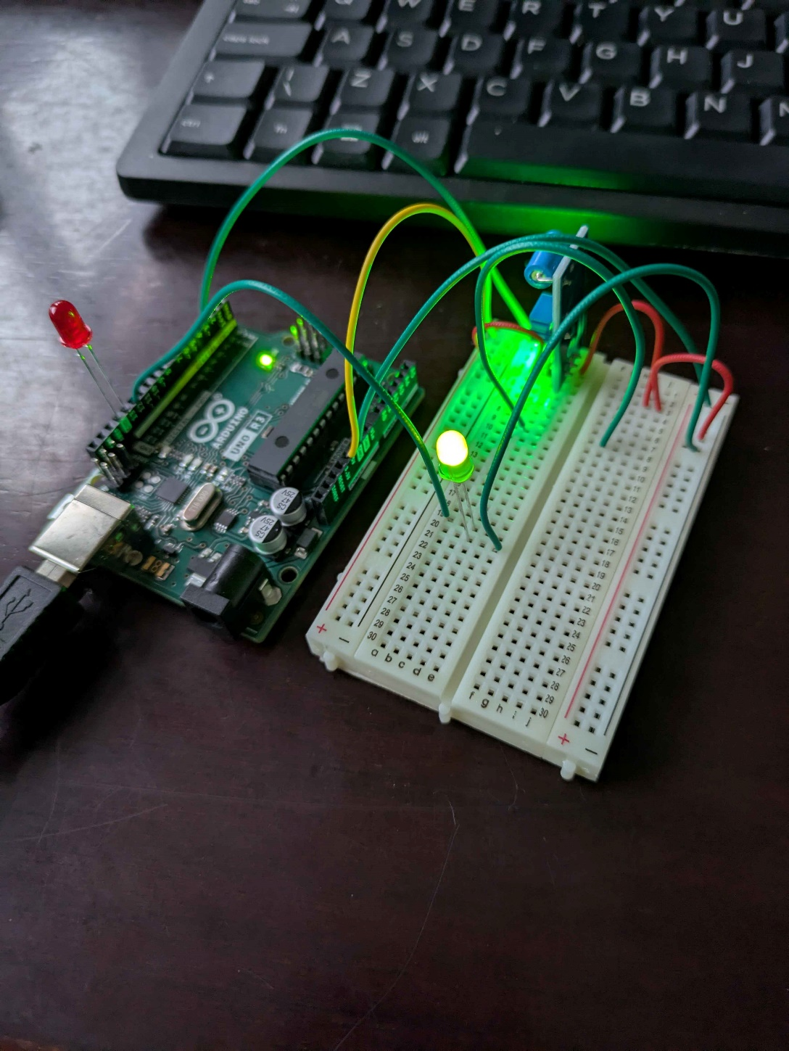

Figure 1.

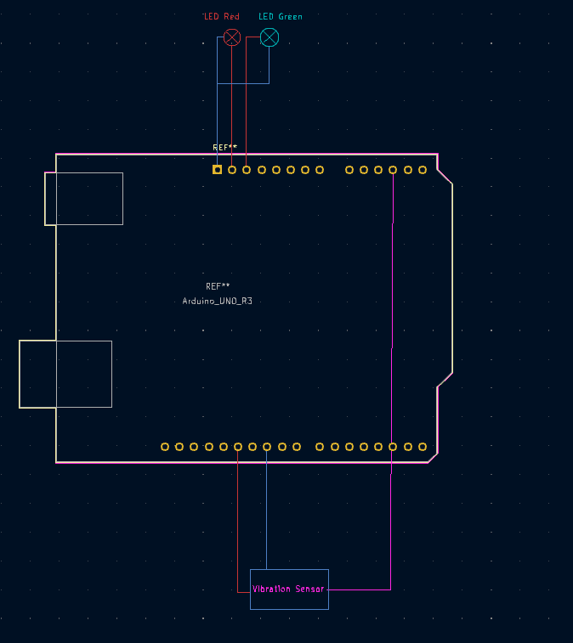

This is the circuit design through KiCAD, it’s easier to visualise its simplicity through this format.

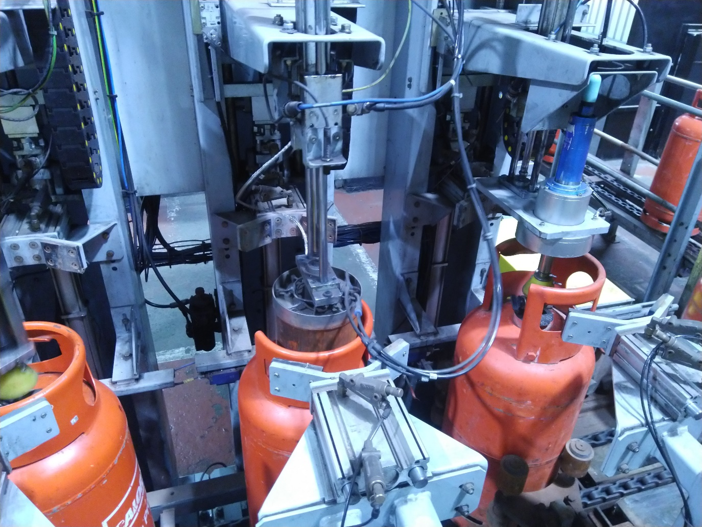

The head down spinner is on the furthest right section and is the last stage of the 3-Stage leak detector.

3.2 Implementation Design

I had a few different thoughts on how the sensor would sit on the machine, this solution was best for sensor health and cable management, it also loops into current systems seamlessly.

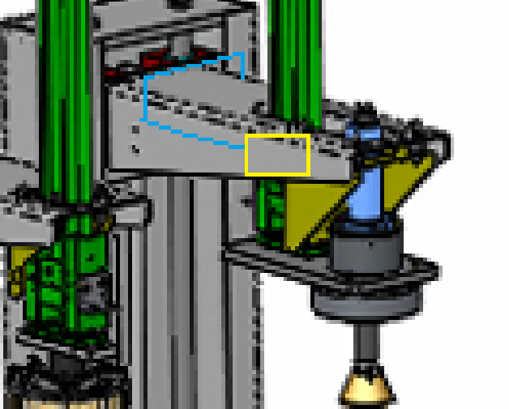

The sensor (yellow box) will sit linearly with the guide rods and head down spinner on a static part of the machine, this allows the Intrinsically safe cables (blue line) to tie into the current power chain on the right side of the machine.

3.3 Software Development

Arduino Code

* Calibrated sensor readings using moving averages and baseline adjustments.
* Used matplotlib and pandas for real time plots and CSV logging (Figure 2)

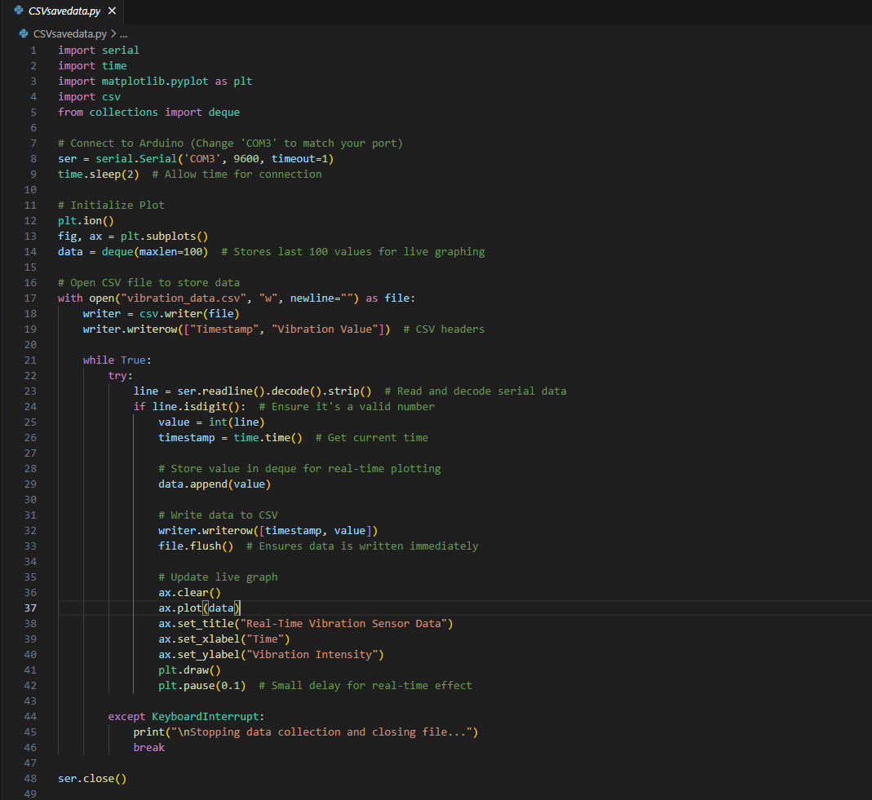

Figure 2.

The software development process was guided by research on real time data analysis and visualisation. The Arduino code was developed in a variation of C++, which has been simplified for commercial use and included basic LED warning system and code for reading the SW-420 data. Python libraries (pandas, matplotlib, numpy, serial, time, CSV) were used for real time data visualisation and CSV logging. The Python script reads data from the Arduino via serial communication (COM3) and plots it in real time while saving the last 100 data points for analysis.

Research into basic Arduino programming and my base knowledge on the subject were important for production of the prototype, also the research was important in gaining knowledge on capabilities and limitations of the Arduino.

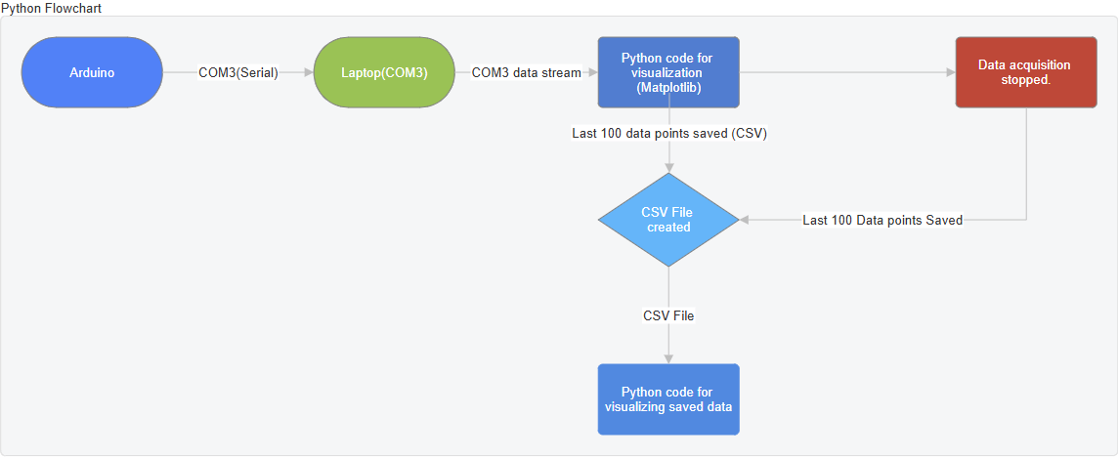

The flowchart above outlines the programs operation, including data collection, hardware and software outputs.

Pre-program algorithm

Initialize Arduino and Python communication (COM3).

Set baseline calibration:

- Read 100 sensor values.

- Calculate average baseline.

Loop:

- Read vibration data from SW-420 sensor.

Send Value to Python via serial communication.

Python:

- Log data into CSV file.

- Plot real-time vibration data using matplotlib.

- Save last 100 data points for analysis.

End loop when program is stopped.

3.4 Testing Protocol

Simulated environments

* A massage gun was used to test at speeds 01 (Low), 15 (medium) and 30 (high) to mimic vibration levels.

Data Analysis

* Theoretical thresh hold alerts were set at 50k (green), 50 – 150k (yellow) and >150k (red)

3.5 Objective 1: Research and Evaluation of Current Industrial Monitoring systems

To address the first objective, a comprehensive literature review was conducted to evaluate existing industrial monitoring systems.

Types of sensors: Accelerometers, piezoelectric sensors and vibration switches were compared for their accuracy, cost and suitability for industrial applications. Studies by Smith et al. (2020) highlighted the limitations of low-cost sensors like the SW-420 in early fault detection, while Wang et al. (2019) emphasised the advantages of FFT, and wavelet transforms for vibration analysis.

Commercial systems: Systems like the Fluke 3563 and TPI-980-EX were analysed for their features, costs and compliance with safety standards. These systems were found to be highly accurate but prohibitively expensive for small scale operations.

Safety standards: Research into ATEX compliance showed the need for energy limiting barriers and explosion proof enclosures in hazardous environments. This informed the safety considerations for the prototype.

The findings from this research were used to identify gaps in existing systems and guide the development of a low cost, Arduino based alternative.

3.6 Objective 2: Development of a Basic Arduino Based Sensor System

The second objective focused on designing and building a basic sensor system using Arduino. The development process included:

Component selection: Based on the literature review, the Arduino and SW-420 vibration sensor were chosen for their affordability and ease of use. A temperature sensor was added to monitor pressure variations indirectly.

Circuit design: The initial prototype used a breadboard to connect the sensor, LED’s and Arduino. The final design created using KiCAD, included serial communication for data transmission to Python.

Testing and iteration: The prototype underwent several iterations to address issues such as sensor positioning and noise, for example the sensor was repositioned to ensure accurate vibration detection, and a moving average filter was researched to reduce noise.

This objective was grounded in practical experimentation, with each design decision informed by the research conducted in objective 1.

3.7 Objective 3: Investigation and Development of a Real Time Monitoring Prototype

The third objective involved developing software for real time monitoring. The process included:

Arduino code: The Arduino code was written in a variation of C and included functions for sensor calibration, data transmission and a LED warning system.

Python integration: Python was chosen for data visualisation due to its extensive libraries. The Python script reads data from the Arduino via serial communication (COM3), plots real time vibration data and logs the last 100 data points in a CSV file.

Flowchart and Algorithm: A flowchart and pseudocode were developed to outline the programs operation (see 3.3 software development).

3.8 Objective 4: Analysis of Hypothetical Collected Data

The fourth objective focused on analysing hypothetical data to identify failure patterns and predictive maintenance needs. The process included:

Simulated testing: A massage gun was used to simulate vibration at three speeds (01, 15, 30), representing low, medium and high vibration levels respectively.

Data analysis: The collected data was analysed to identify patterns and outliers. Thresholds were set at 50k, 50k –150k and over 150k, to simulate predictive maintenance scenarios.

Failure patterns: The data revealed consistent vibration patterns at each speed, with outliers indicating potential faults, for example spikes at high speeds (30) suggested over pressurisation or mechanical failure/wear.

This objective was informed by research on predictive maintenance and demonstrated the prototypes potential for identifying failure patterns.

4.Results

4.1 Prototype Performance

Vibration detection

* Speed 01: Peaks at 30k – 50k (baseline noise, Figure 4).

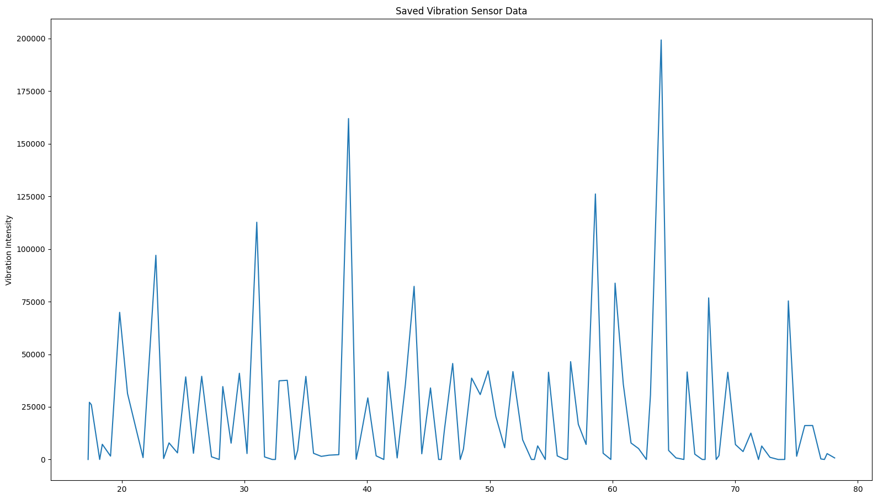

* Speed 15: Peaks at 100k – 200k with outliers (Figure 5).

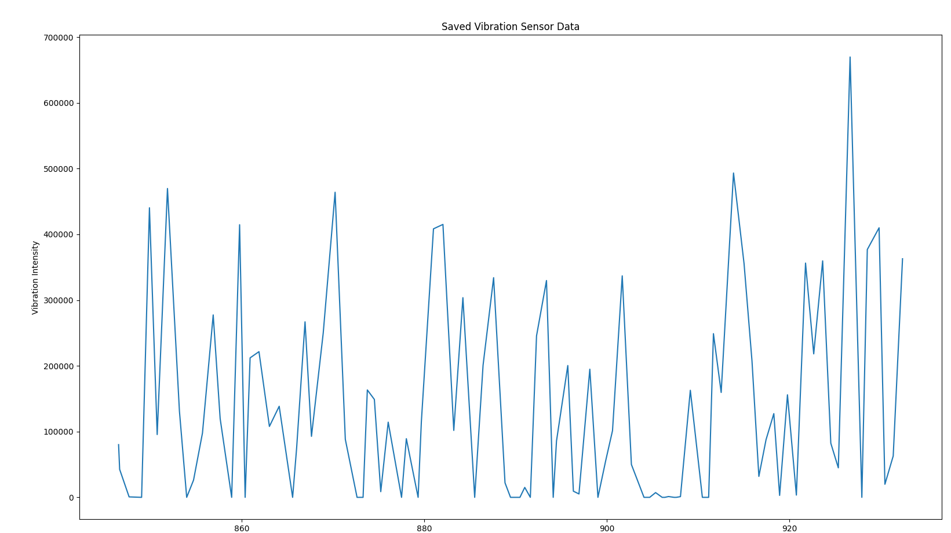

Figure 5.

* Speed 30: Consistent peaks at 200k – 400k vibration intensity (Figure 6).

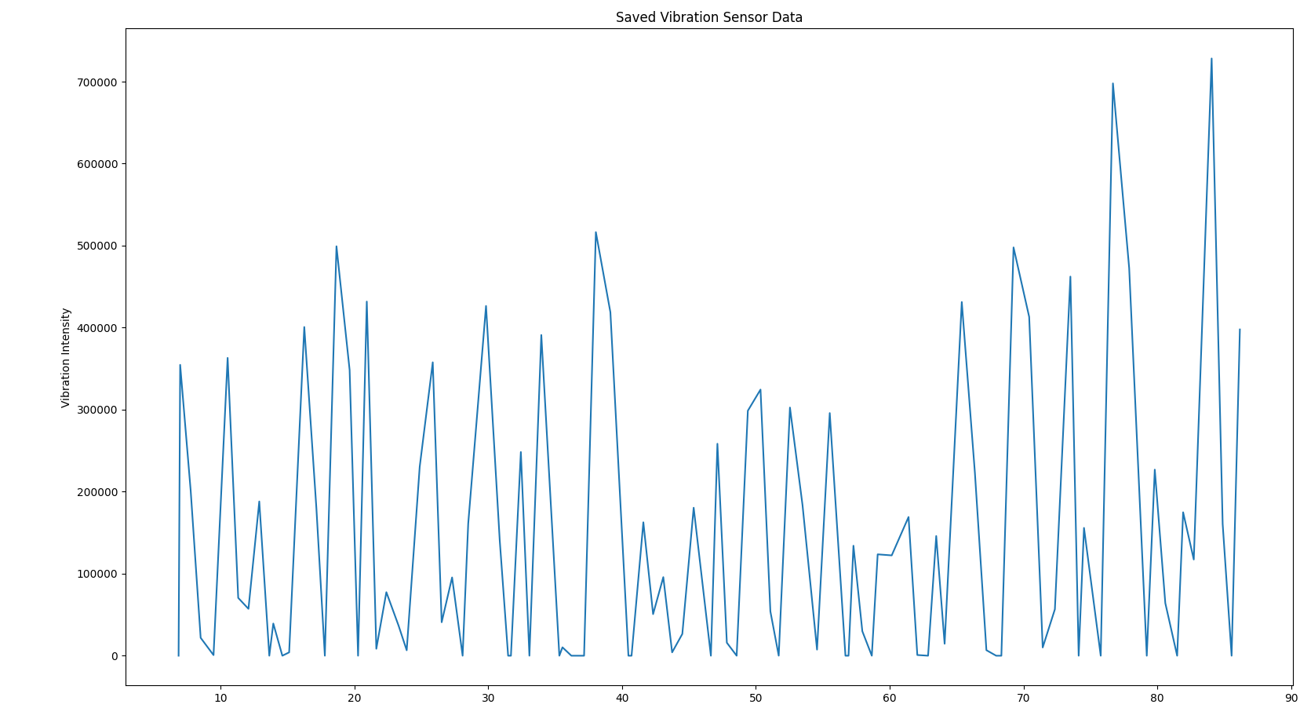

Figure 6.

Python Visualisation

* Real time graphs showed latency but confirmed functionality.

4.2 ATEX Compliance Challenges

Sensor limitations: The SW-420 lacks certification; false positives occurred because of double reading and potential electrical noise.

Proposed Solutions:

Option 1 – HS-105IS ATEX-certified sensor (£450) with IS barriers

Option 2 – Explosion proof enclosure, which risks data inaccuracy.

4.3 Threshold look-up table

|  |  |  |
| --- | --- | --- |
| Vibration Intensity | LED Alert | Action |
| <50k | Green | Normal Operation |
| 50k – 150k | Yellow | Moderate Vibration |
| >150k | Red | Extreme Vibration (Fault) |

5. Discussion

5.1 Technical Feasibility

The prototype demonstrated the potential of low-cost vibration monitoring system for industrial applications. However, the SW-420 sensors limitations in accuracy and resolution highlight the need for more advanced sensors in high precision environments. Critically evaluating the prototype system and research gathered through literatures, it's easy to conclude that the project is not technically feasible for large scale hazardous industries but is more suited to start up small to medium scale industries, as more of a failure response that could be linked to an emergency shutdown (ESD).

Research found that industrial monitoring systems may be more costly in comparison to our prototype, but it found that there is a good reason for, as often commercial industrial monitoring systems are more accurate, safer and easier to implement onto industrial machinery. It also showed the importance of adhering to safety standards and the added costs of these requirements, often adding 5 to 10 times of what would be an item expected cost to achieve ATEX certification.

Strengths:

* Modular design enabled rapid prototyping.
* Python data logging allowed retrospective analysis.

Weaknesses:

* SW-420 inaccuracies (double reading).
* Lack of adaptive thresholds for dynamic environments.

5.2 Safety Compliance

Rob (Calor Gas Engineer): Emphasised IS barriers and shielded cables to mitigate ground loops and ensure safety in hazardous environments. The current prototype, while functional lacks ATEX certification, making it unsuitable for deployment at Calor gas. Research and investigation from Rob and other engineers, highlighted the potential limitations with installation of this equipment in our ATEX zone.

Barry (Calor Gas Mechanical Engineer) highlighted that vibration in the machinery isn’t uniform, so mounting it near the spindle could give false readings due to rotational harmonics. Also, he brought into considerations environmental factors like dust and moisture, as well as potential gas discharge from the bottles which could easily degrade the sensor accuracy over time.

Hybrid approach: Prototype with Arduino and deploy with TPI 9080-Ex for ATEX compliance.

5.3 Cost Benefit Analysis

Arduino system: £120 vs £3500 for industrial systems, this offers a significant cost advantage, making it an attractive option for smaller scale operations or as a proof of concept for larger scale deployments. However, trade-offs in accuracy and maintenance efforts need to be considered. The low-cost SW-420 sensor lacks resolution to detect minor faults, like bearing wear or damper ring damage and requires frequent calibration to maintain accuracy. Also, the systems reliance on basic filtering techniques increases the potential for false positives.

Trade-offs: Lower accuracy, higher maintenance efforts.

6. Conclusion

The prototype demonstrated the viability of low-cost vibration monitoring, but highlighted critical gaps in ATEX compliance and sensor accuracy, the prototype could work effectively in small non-hazardous industries that want a preliminary vibration monitoring system designed for machine safety, as the SW-420 sensor lacks the resolution to see minor faults and fluctuations, but will be able to see larger ones that create more vibration. Future work could explore the integration of machine learning algorithms or wavelet transforms to enhance data analysis and fault detection capabilities."

The research demonstrated the feasibility of a low-cost system, however highlighted the benefits and accuracy of commercial industrial systems, it also showed the importance of compliance to regulation and how this compliance drives up the cost of these commercial systems through ATEX certification. Research also showed the need for extensive literature review prior to prototyping and on reflection, more research could have been carried out if the acquired data was of better quality.

Future work will:

* Consider integration of HS-105IS sensors and IS barriers.
* Implement wavelet transforms for advanced fault detection.
* Collaborate with Calor Gas engineers for field testing.
* Research alternatives to Arduino, like raspberry pi for data Aquisition due to higher processing speeds.
* Consider more Indepth research into specifics of current commercial solutions, with an emphasis on how data is collected accurately.